Response to change

Solution

Step 1:

Think of two change experiences you have recently experienced and on the template provided, provide an overview of what the change was.

1. A change imposed upon you – where you felt like you didn’t have a choice in the change. It can a be a small or large change; gradual or sudden; expected or unexpected.
2. An intentional change where it was a conscious decision by you to initiate or support a change.

|  |
| --- |
| Change that was imposed on me:  A recent change that was imposed on me was while via pandemic situations arising, we were trying to be aware of our surroundings all the time, keeping a check on our health and what we eat, who we touch and where we go. Alongside working from home and on computers to manage a work and family life balance without geographic relocation. |
| Change that was intentionally generated by me:   * Making the changes that align with work. * Eating Healthy. * Keeping assert fitness regime by exercising and site link to avoid repercussions of stagnant body while working from home . * Making up a new work from home set up which involves up top for table chair abort people plantation I love talk with high speed Internet . * Engaging in virtual internships alongside virtual webinars and Bing much more online than before be aware about the upcoming news . |

Step 2:

Think about and record the range of reactions you experienced (mindset/emotions and behavior) as you went through the changes – from the beginning to the end.

|  |
| --- |
| The range of reactions experienced for the change that was imposed on me was:   * Initial frustration on not able to engage in social activities. * Depending on inner connection more than outer connections. * Having outrage of emotions but unintentionally targeting them over people co-living. * Making sure that neither anyone gets unhealthy nor anyone gets depressed in loneliness. |
| The range of reactions experienced for the changed that I intentionally generated was:   * Having an urge to do something productive in these times . * Keeping check on health. * Maintaining good relationships and honest communication with people around. * Donating sum of money to organizations that are willing to help. |

Step 3:

Complete the reading and research in the additional resources to get a better understanding of ‘why’ you experienced what you did and then complete the next page.

Step 4:

Now that you’ve done your research about the Change Curve, please complete the final section. Here is a reminder of the Change Curve:

The Kübler-Ross change curve

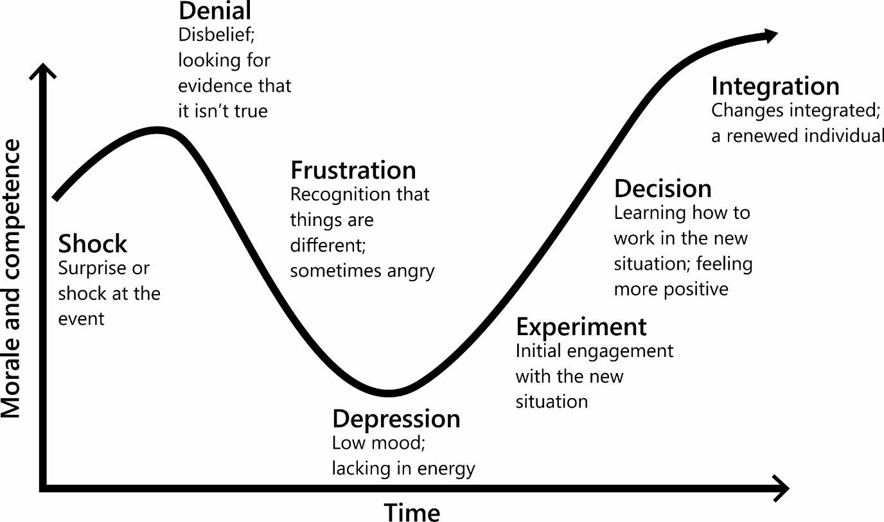

Step 5:

Identify what you have learnt from reflecting on this experience. Thinking back to the changes you wrote about earlier, identify what you have learnt from reflecting on this experience. It would also be beneficial to detail what happened at each stage of the Change Curve for you.

|  |
| --- |
| My reflections and learnings for the change that was imposed on me:   * That we are quite adaptable to situation and can't find our ways even in the hardest times. * Media is not always correct as they are exaggerating emotions over facts. * Being self sufficient counts as we are much less connected to each other. |
| My reflections and learnings for that change that I intentionally generated:   * Started actively engaging on the pending projects. * Spending time with loved ones is as essential as working. * Open should Stop having myopic view and start accepting how changes affects humanity and other life forms as a whole. |

Any final thoughts or reflections on how you could deal with change more effectively in the future?

* By being prepared for health challenging situations.

* Accepting sustainable development.
* Living by each other's happiness and not by each other's misery.
* It's not about how hard you get it about how hard can you get hit.
* Keep busy living or keep busy dying.